Cell Stem Cell Guide:

The Summary is a single paragraph no longer than 150 words. An effective Summary includes the following elements: (1) a brief background of the question that avoids statements about how a process is not well understood; (2) a description of the results and approaches/model systems framed in the context of their conceptual interest; and (3) an indication of the broader significance of the work. We discourage novelty claims (e.g., use of the word “novel”) because they are overused, tend not to add meaning, and are difficult to verify. Please do not include references in the Summary.

**Title: DNA Methylation changes in Human Intestinal Epithelial Organoids with Increasing Passage**

Organoids are a powerful tool to model major aspects of development, health and disease. A necessary aspect of organoid models is the expansion of cultures *in-vitro* through several rounds of passaging. This is of concern as high passaging of cell cultures has been shown to have effects on cell morphology and function. We have generated 80 human intestinal organoids from two sampling sites, terminal ileum and sigmoid colon and examined the effect of passage on DNA methylation (DNAm). We observed DNAm changes at 61,337 CpGs associated with passage. High passage organoids are globally hypomethylated and locally hypermethylated, with greater variability in DNAm with increasing passage. We were able to validate the passage effect in an additional 76 publicly available organoids, including pancreas, rectum, stomach, and lung organoids. These results suggest limits on the utility of organoids and that they should be considered a decreasingly meaningful model with increasing passage.

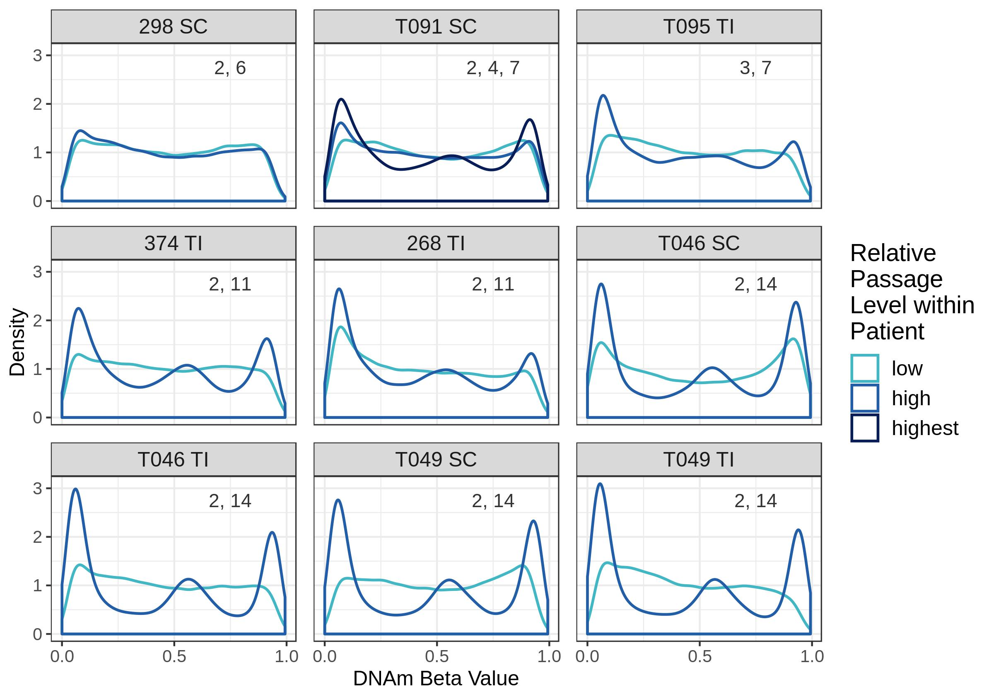

**Figure 1. DNAm beta value distributions are trimodal for high passage samples but bimodal for low passage samples, even within an individual.** DNAm beta value distributions for samples derived from the same patient but cultured to a different number of passages. Distributions displayed are for the 51,545 most variable CpGs. Plots are labelled with the patient ID number, sampling site of origin (TI:terminal ileum, SC:sigmoid colon) and the passage number of each organoid derived from that patient and sampling site. Curves are coloured by high or low passage relative to the other sample(s).